
EL643AW（R100）

Product features
- Onboard Intel Elkhart Lake J6412 series processor
- 2*DDR4 SO-DIMM，MAX 32GB
- 2*i226-V LAN Card，Single and dual network options；
- TPM2.0ptional，3*M.2（SSD/WIFI/4G/5G）
- HDMI2.0/DP/LVDS/EDP display output
- DC 9-36V；
- Size：146x102mm

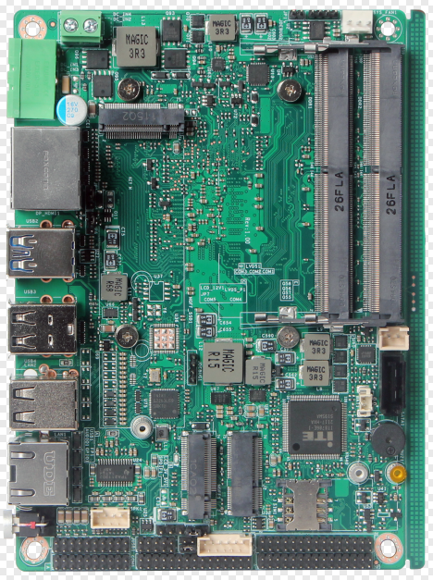

Processor system | Onboard Intel Elkhart Lake series processor
Processor system | EFI BIOS
Memory | 2 DDR4 SO-DIMMs, maximum 32GB
storage | One M.2 M-Key 2280 (NVMe PCIe 3.0 x4/SATA3.0 protocol) storage interface
storage | 1 SATA3.0 interface, 2Pin power supply
display | 1 HDMI2.0 interface, supporting 4096x2160@60Hz
display | 1 DP1.4 interface, supporting 4096x2160@60Hz
display | LVDS/eDP
Board side I/O interface | 2Pin through-wall terminal, HDMI, DP, power-on button
Board side I/O interface | 4 USB, 2 RJ45. (6 USB for single network)
Expansion interface/function | TPM2.0 is optional, but not by default
Expansion interface/function | One M.2 E-Key (PCIe+USB2.0 protocol, supporting WIFI module)
Expansion interface/function | One M.2 B-Key (USB2.0/USB3.0 protocol, supporting 4G/5G module); 1 Micro SIM card slot
Expansion interface/function | 6 COM row pins, 2x5Pin, spacing 2.0mm
Expansion interface/function | 2 sets of 4 USB2.0 rows of pins, 2x5Pin, spacing 2.0mm
Expansion interface/function | 1 set of 8-bit GPIO pin, 2x5Pin, spacing 2.0mm
Expansion interface/function | 1*3Pin SYS FAN，1*3Pin CPU FAN
Power Supply | DC 9-36V，30W
work environment | Working temperature: - 20 ℃~+60 ℃; Working humidity: 5%~90%
work environment | Storage temperature: - 40 ℃~+85 ℃; Storage humidity: 5%~90%
Operating system support | Windows10，Windows11，Linux
size | 146x102mm
Net weight | About 120g without radiator, about 200g with radiator
EL643AW（R100）

size 单位：mm
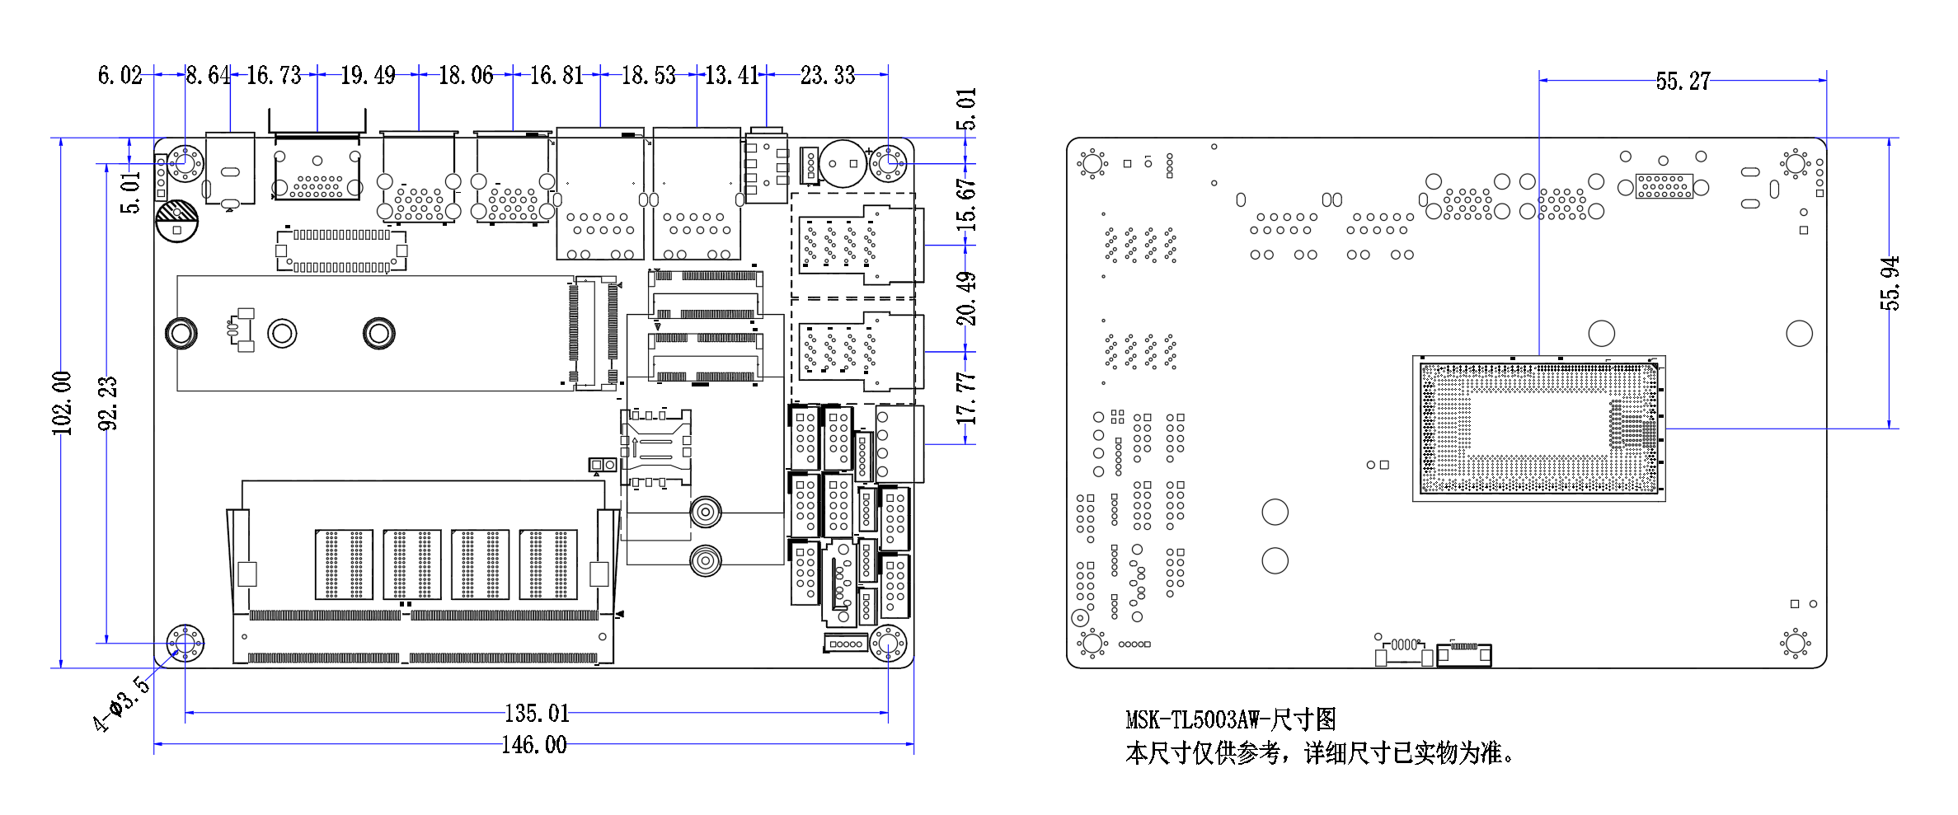

ordering information
Model | Optional | Optional description
EL643AW | Onboard Intel Elkhart Lake series processor | J6412/X6413
EL643AW | TPM2.0 | TPM2.0 optional
EL643AW | Single and dual network options | Single and dual network options
EL643AW | COM optional | Default 2, optional 6
EL643AW | LVDS/EDP | LVDS/EDP optional
EL643AW | Board side power interface | 2Pin Phoenix terminal or DC JACK

