
C-BOX-M4（R100）

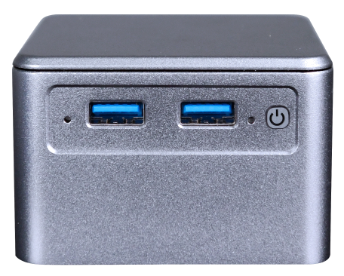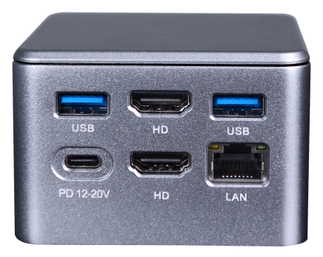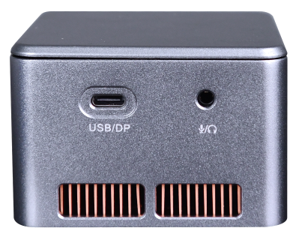

Product Specification
Processor | Onboard Intel Alder Lake-N series processor, N95/N300
Processor | EFI BIOS
Memory | Onboard LPDDR5x memory, up to 16GB
Storage | 1*M.2 M-Key 2242(NVMe PCIe3.0 x2/SATA3.0, Protocol adaptation ）
Extension ports | M.2 E-Key，(PCIe3.0 x1 + USB2.0 protocol），WIFI/BT
I/O ports | 1*RJ45 LAN（Intel i226C-V ethernet controller supports 2.5G）
I/O ports | 2*HDMI2.0, 1*Type-C (USB+DP), 2-in-1 audio jack
I/O ports | 4*USB3.0
I/O ports | Power button, 1*reset hole
I/O ports | Type-C power input, supports PD power supply
Power supply | DC 12-20V, 3A/PD
Working environment | Operating temperature: -20℃ ~ +60℃； Working humidity: 5% ~ 90%
Working environment | Storage temperature: -40℃ ~ +85℃； Storage humidity: 5% ~ 90%
Operating system | Windows10, Windows11, Linux
Size | 75x75x52 mm
Material | Aluminum alloy, Plastic top cover
Weight | About 0.5kg

Ordering Information
Model | Optional Items | Description of options
C-BOX-M4 | Onboard Intel Alder Lake-N series processor | N95/N300
C-BOX-M4 | Onboard memory | 8GB/16GB optional

